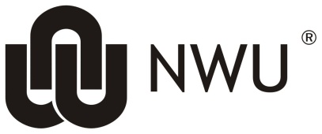
NWU-EMELTEN-REC

The Faculty of Health Sciences Ethics Office of the North-West University is acknowledged for the use of their document with minor adjustments made by the NWU Education, Management and Economic Sciences, Law, Theology, Engineering and Natural Sciences Research Ethics Committee (NWU-EMELTEN-REC).

INDEMNITY FORM (NWU-EMELTEN-REC)

I, the undersigned

______________________________________________________

identity number: ______________________________________,

hereby indemnify the North-West University (“NWU”) and/or any of its office-bearers and staff (temporary or permanent) against any liability in respect of personal losses and/or damages suffered by me or any other person arising from or resulting as a consequence of my participation in the research entitled ____________________________________________________ (the “Research”), and hereby hold harmless the NWU against above-mentioned liability.

I confirm that I voluntarily consent to participate in the Research, and that I was in no way forced or coerced by the NWU to participate in the Research, and that the waiver and release shall apply to any claims that may arise during and/or after the Research.

I declare that I am aware of the risks involved in the Research, as explained to me, and of the implications of this waiver and release, and agree that this document shall also be binding upon my executor, curator or other assigns.

Signature ___________________________________

Date ___________________________________

